10 Proven Tips for Conducting Successful Remote Interviews

How do you conduct effective remote interviews? Looking for remote interview tips?

By now, most of the organizations have implemented work from home or remote working for their employees!

While working from home has hassles of its own, the real challenge occurs in recruiting individuals. No matter how experienced you are in interviewing people, the shift to an entirely remote recruitment plan is going to be a tough nut to crack.

You have to be prepared with your questionnaire, video conferencing equipment, and align other things right in time for the interview. Even if you do all of this successfully, it is complicated to analyze a candidate from their nonverbal cues from video conferencing.

But, there’s nothing to worry about!

You can still conduct successful interviews and hire the best employees for your organization. Just keep these 10 smart tips in mind!

1. Review Your Current Interview Process

If you’re shifting to remote interviewing, it’s a good time to re-evaluate the process you already have. Is it effective? Is it structured? What can you do better?

Most companies don’t have a dedicated hiring process. It’s not about meeting another person. Your process should allow candidates to move reasonably quickly through a clear sequence of steps that feels personal to them.

Keep the communication clear while you’re hiring remotely. These are basic elements that candidates will need to know ahead of time:

- Who will they be meeting from your team?
- What should they prepare?
- Will it be an audio call or a video call?
- Will you want them to share their screen at any point?
- What tools or apps will you want them to use? And do they need to download and test them ahead of time?

If you want to hire great talent, then improve your remote interview process.

2. Create a Definitive Plan

Since you can’t go asking questions from desk to desk, you should formalize the hiring plan with your entire team. Start by asking the most relevant questions about the new hiring strategy and then work on them one by one.

Consider whether the candidate needs to go through pre-assessment or what communication channels do you need to have in place for conducting the interview.

3. Introduce candidates to the company virtually

While you’re hiring virtually, create a branded content package that candidates can review in their free time to get a feel for the company’s culture and values.

Here are things you can consider:

- Include major company announcements or press and media coverage.
- Employee profiles,
- Glassdoor reviews.
- Customer testimonials.
- Team celebration photos and videos.
- Benefits and perks.

4. Prepare Your Tech

The foundation of remote interviews is tech. This is one of the parts of the remote hiring process that will demand most of your attention.

Make sure you have a good internet connection, along with other nuances. Since internet issues are not new, also prepare yourself with an alternate mode of communication that you may need to use when there is a connectivity problem in the network. Try to test your equipment in advance to minimize such issues.

5. Plan your Time Frame and Be Appropriately Dressed

When conducting remote interviews, make sure you give other people an ample amount of time to set up their tech as well. Remember that it’s not just you who will be sitting through the interview, but the candidate as well.

Inform your candidate as early as possible and ask them to keep their phone, laptop, internet connection ready, and tested before the interview. The more clear directions you provide to the candidate, the smoother will be the interview process.

No matter if it's a remote interview or an onsite interview, the underlying ethics remain the same. Make sure you are formally dressed for the interview so that the culture and seriousness of your workplace are evident to the candidate. It is advisable to add request your candidate to do the same.

Don’t forget that dressing up formally is little about the clothes and more about the culture that you bring to the table.

6. Choose an Undisturbed Space

Working from home can be quite an experience, especially when you have little children in your house. Make sure that you pick a quiet and undisturbed place of your residence to conduct the interview.

This will help you listen and understand the candidate in a much better manner. Also, ask the candidate to choose a quiet and well-lit environment for the interview.

7. Take Feedback After the Interview

Always take feedback after the interview. This way, you will learn from your experience and understand the areas where the remote recruitment process needs improvement. Prepare a survey and keep it simple.

For example, you can ask questions like how could the interviewing process be improved, or was the software or platform chosen for the remote interview convenient, etc.

8. Don’t Reinvent Your Questions

A lot of things have to be improvised during the process of remote interviews. This process already changes the dynamic between the recruiter and the candidate. To minimize any gaps, the best you can do is ask your candidates a consistent set of questions that you have been asking during regular on-site interviews.

It makes sure that you can still judge a candidate based on their merit, even if there are a lot of disturbances in the tech or connectivity.

9. Have a Back-Up Plan in Place

No matter how good your tech is or how many times you’ve tried and tested it, you cannot wholly rely on it during an interview.

To value your and your candidate’s time, it is best that you have a back-up plan in place. Whether you would like to switch to a voice call or a video call on WhatsApp, be prepared with the next possible set of actions, and also inform your candidate about them well in time.

10. Discuss the challenges of Remote Work

Despite its main benefits, remote work comes up with unique challenges. Remote workers have to manage their time and schedule, which can lead to a lack of working structure.

When conducting a remote interview, you must discuss an interviewee’s experience and hesitations about remote work.

HR leaders should encourage candidates to identify solutions that may help them succeed within your remote team.

Here are some sample questions you can ask:

- Have you ever worked remotely? What were some of the challenges you faced, and how did you tackle them?
- Have you worked with a distributed team? How did it go?
- How do you communicate with a remote team?
- How do you stay focused on your schedule and tasks?
- How do you switch off from work?

Bonus: Top 5 Tools For Remote Interviews

1. Zoom

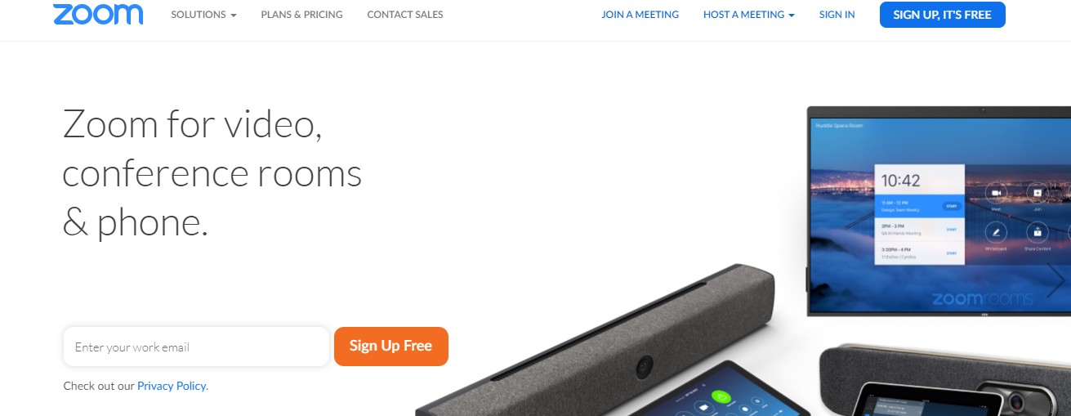

2. Google Hangouts Meet

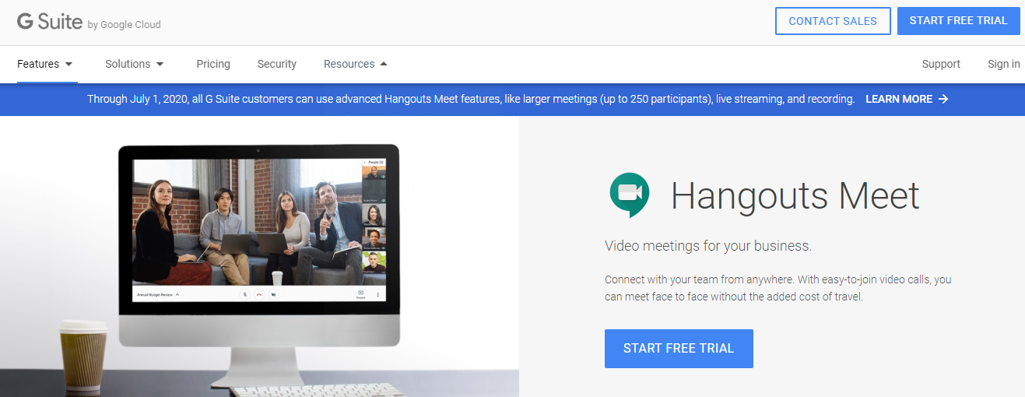

3. Skype



4. GoToMeeting



5. Join.me



Conclusion
Remote interviews can be tough, even with the comfort of our homes. However, with adequate planning and a set of prepared actions, you can minimize the hassle and disturbances in between. Remember to be compassionate with the candidate and considerate about their flexibility in appearing for a remote interview.

Reflect the culture of your company and respect your candidate by keeping the background sounds at a minimum. Remember that patience is the key to a successful interview.

